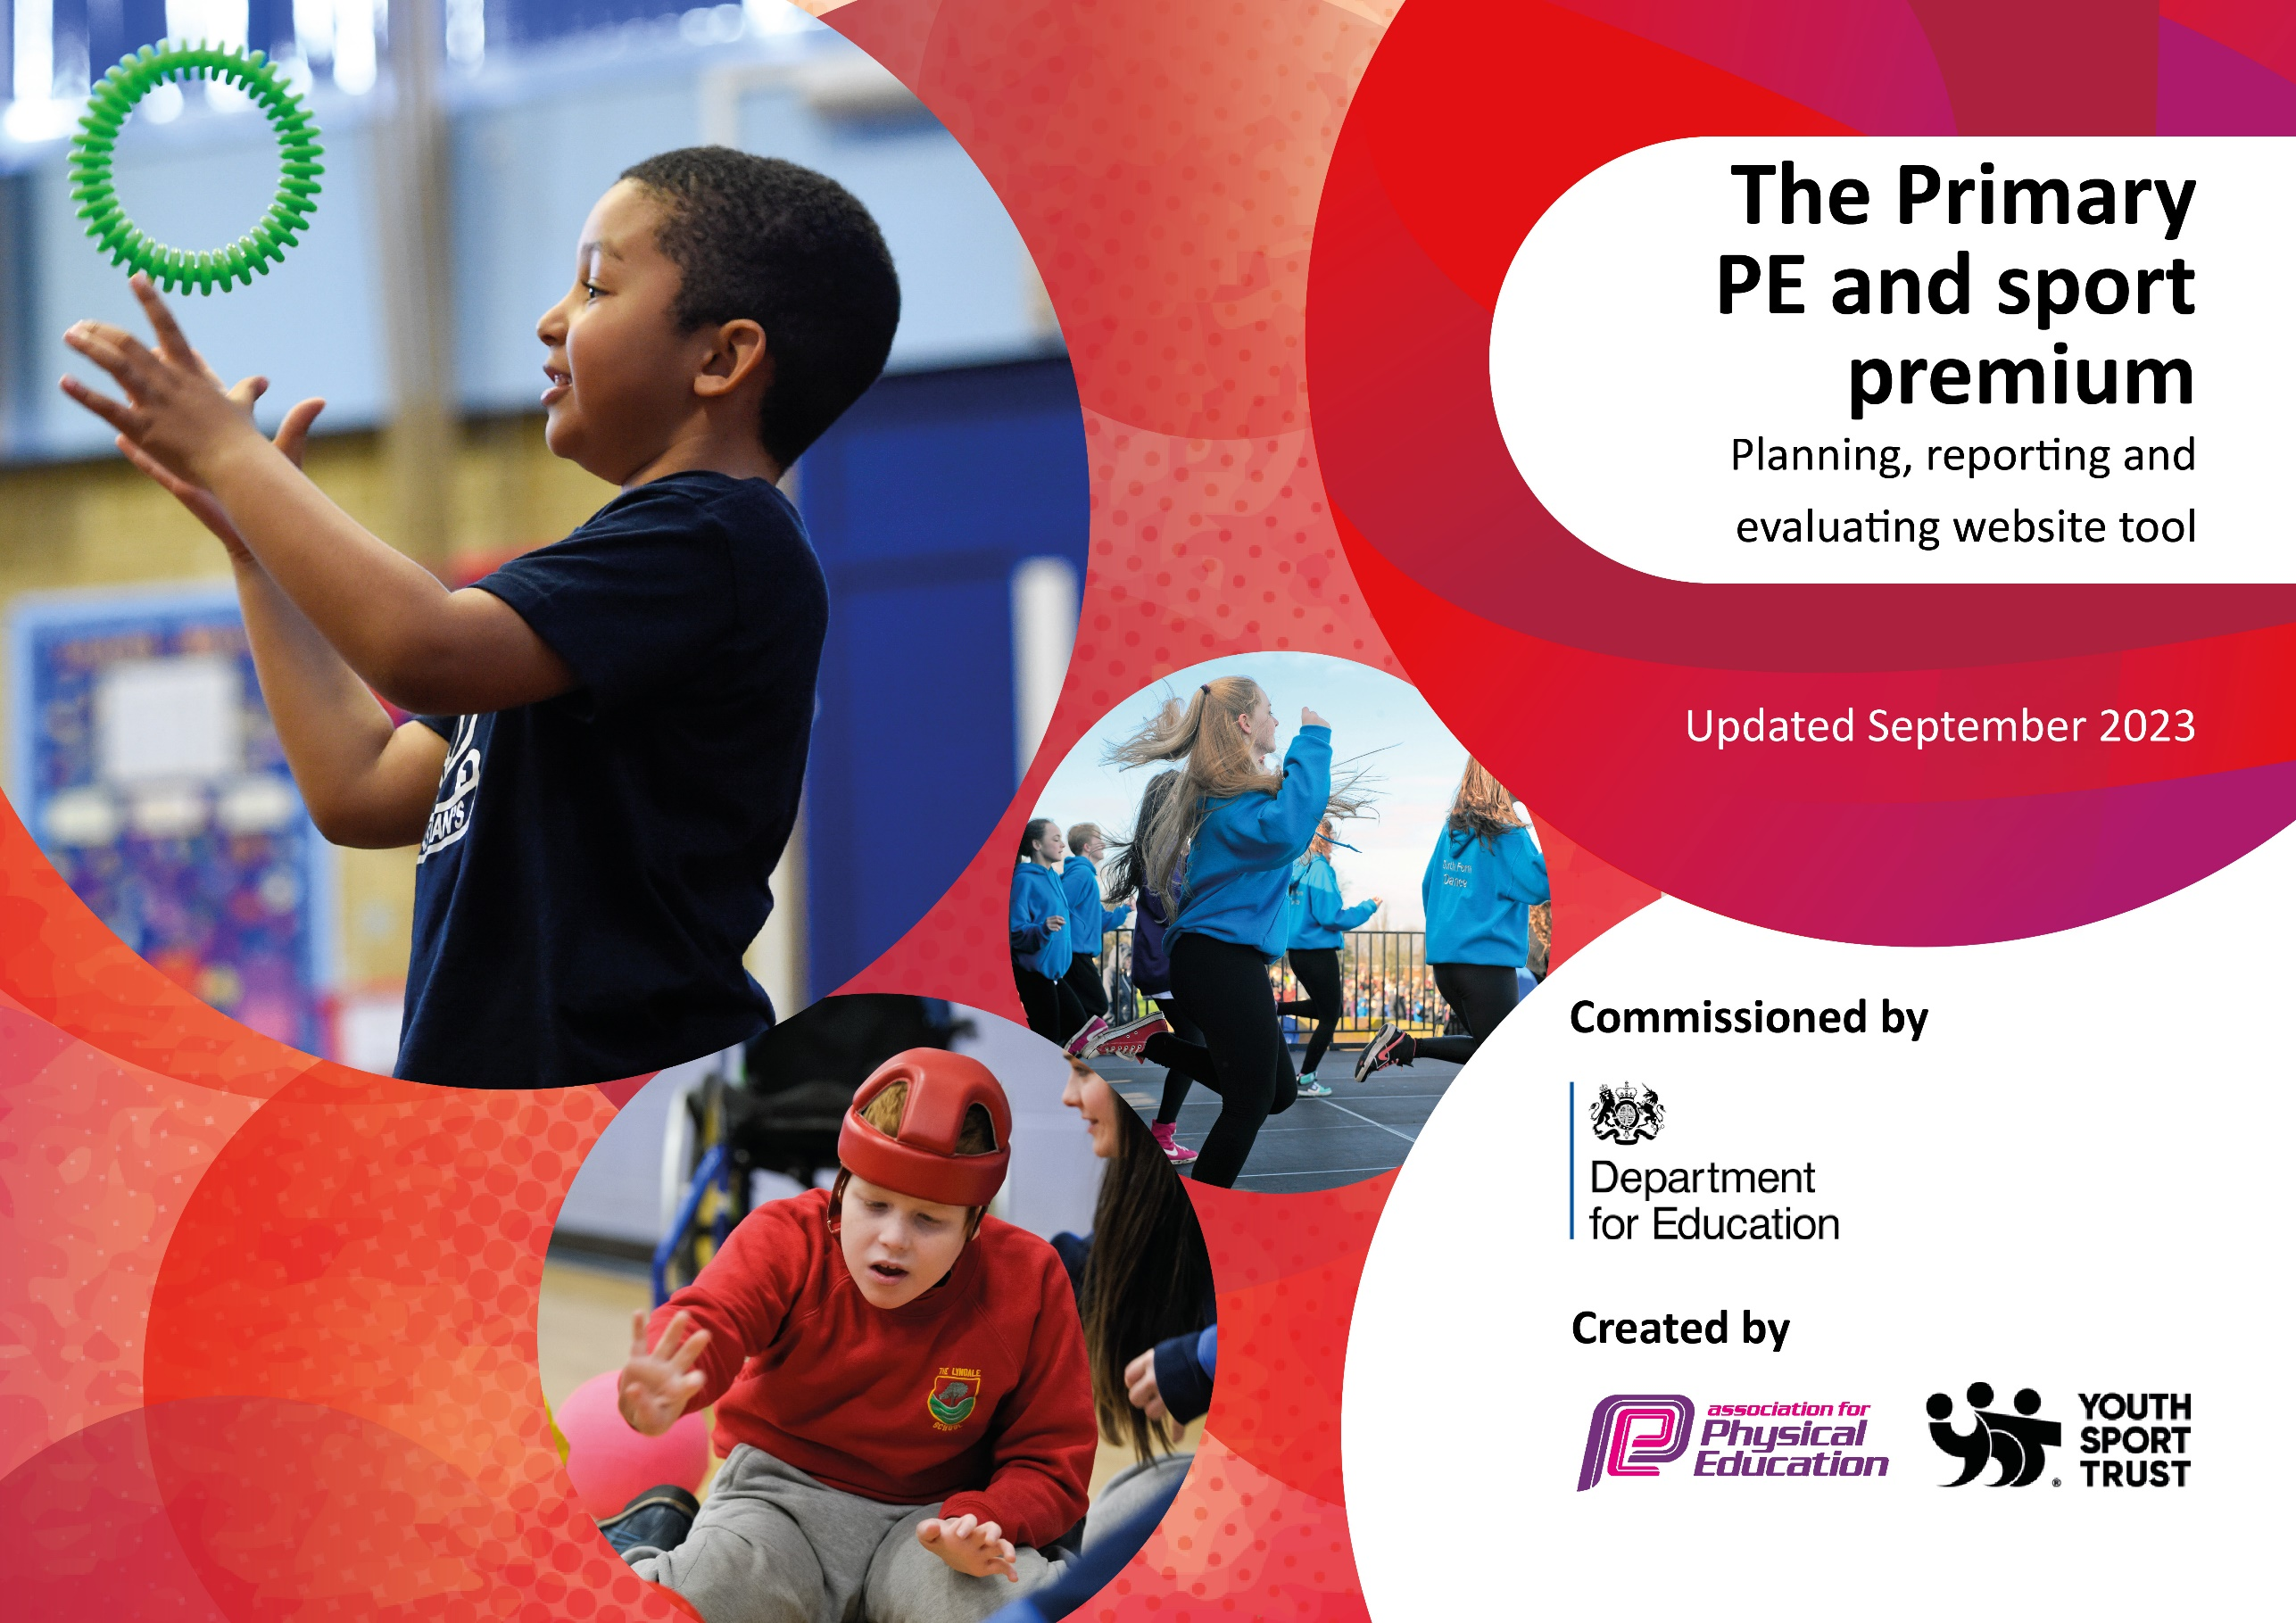

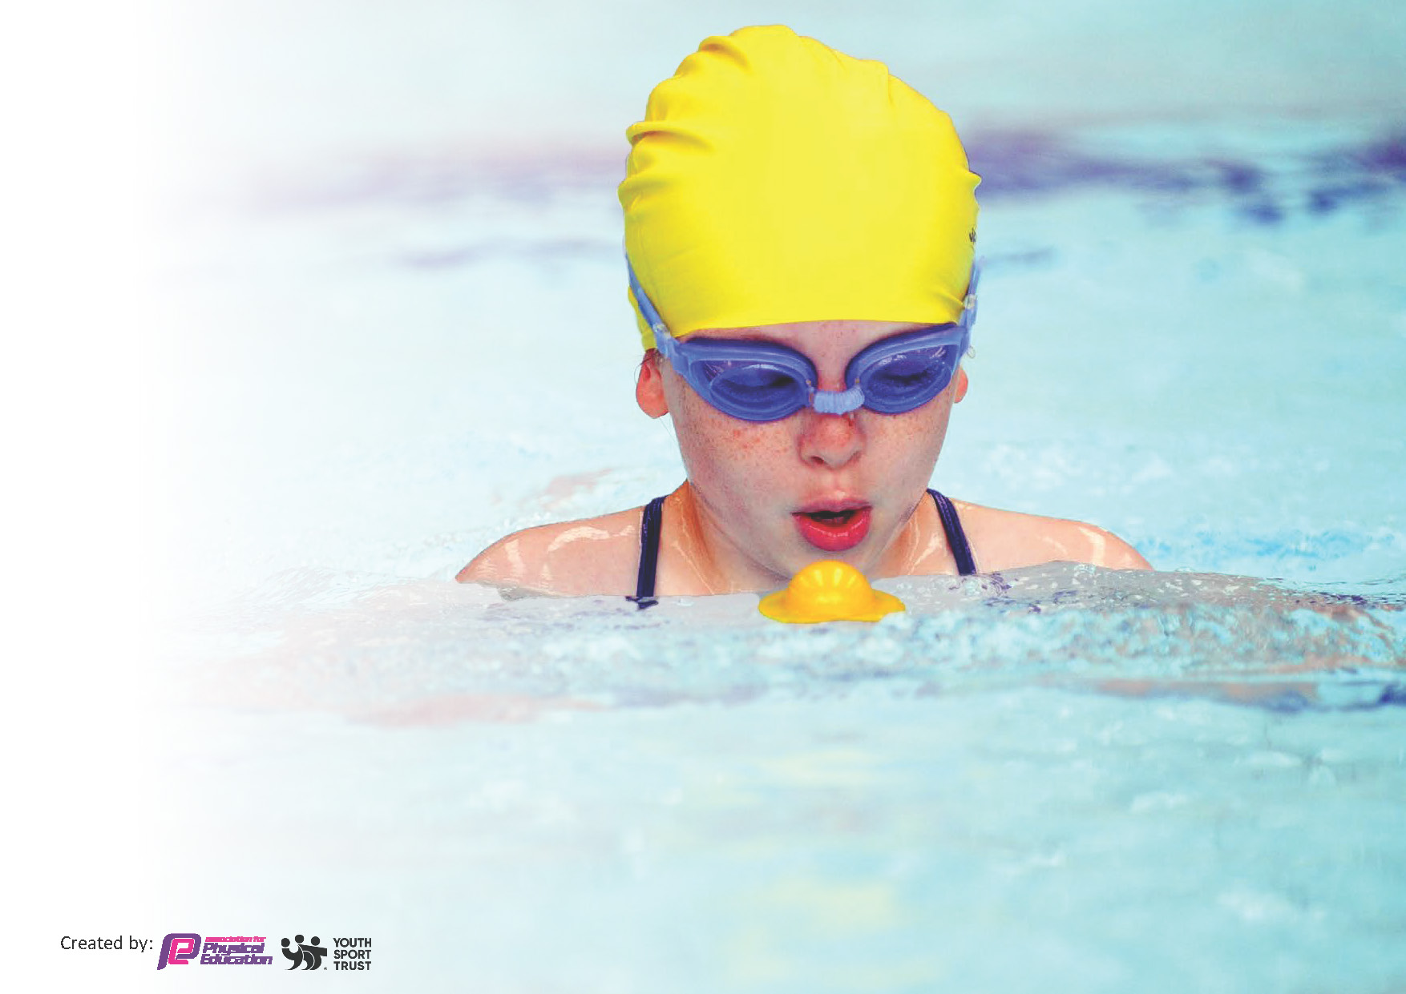
This template can be used for multiple purposes:
by:
- It enables schools to effectively plan their use of the Primary PE and sport premium
- It helps schools to meet the requirements (as set out in guidance) to publish information on their Primary PE and sport premium
- It will be an effective document to support Ofsted inspections enabling schools to evidence progress in Physical Education (PE) and evidence swimming attainment, which forms part of the PE National Curriculum. We would recommend schools consider
the Intent, Implementation and Impact of any spend, as examined within the Education Inspection Framework.

It is important that your grant is used effectively and based on school need.

Schools must use the funding to make additional and sustainable
improvements to the quality of the PE, School Sport and Physical Activity (PESSPA)
they offer. This means that you should use the Primary PE and sport premium to:

- Build capacity and capability within the school to ensure that improvements made now will benefit pupils joining the school in future years
- Develop or add to the PESSPA activities that your school already offers.

The Primary PE and sport premium should not be used to fund capital spend projects; the school’s core budget should fund these. Further detail on capital expenditure can be found in the updated Primary PE and sport premium guidance.

The Primary PE and sport premium guidance, outlines 5 key priorities that funding should be used towards. It is not

necessary that spending has to meet all the key priorities, you should select the priorities that you aim to use any funding towards.

Although completing this template is not a requirement for schools, schools are required to publish details of how they spend this funding. Schools must also outline what the impact this funding has had on pupils’ PE and sport participation and attainment and how any spending will be sustainable in the future. All funding must be spent by 31st July 2024.

The Department for Education has worked closely with the Association for Physical Education (afPE) and the Youth Sport Trust (YST) to develop this template and encourages schools to use it. This template is an effective way of meeting the reporting requirements of the Primary PE and sport premium.
Review of last year’s spend and key achievements (2022/2023)

We recommend you start by reflecting on the impact of current provision and reviewing your previous spend.

Activity/Action | Impact | Comments
- Purchase of bikes and plan put in place for timetable, support through Bike4Health  - Year 4 to cycle to Hadrian Leisure for their swimming lessons to cut the cost of a coach for parents and school  - To have more children involved with sports outside of school and to attend local clubs | - Only a few children in each year group can now not ride a bike. All children made progress and many can now ride a bike who couldn’t at the beginning of the year.  - Most children cycled to and from the swimming pool for their lessons.  - More children have signed up to local clubs such as Wallsend Boys Club, swimming at Hadrian Leisure, local judo club. | - The bikes have been a huge success with all children have the opportunity to cycle from Years 3-6. We have moved away from Bike4Health and now run our own bike timetable using our own trained staff.

Key priorities and Planning
This planning template will allow schools to accurately plan their spending.

Action – what are you planning to do | Who does this action impact? | Key indicator to meet | Impacts and how sustainability will be achieved? | Cost linked to the action
Work with Bike4Health to help support our children and staff when beginning cycling curriculum  Introduce Judo to our after school club offer  Wallsend mini soccer project to support KS1 children in PE  Coach for SEND Tennis Competition  Coach for Dance Festival rehearsal  Take part in Dance Festival  Sports Day equipment – Megaphone  Coach for Year 1 Multi-skills festival  Jamie Knight – Freestyle Football workshop and assembly  Eagles workshop – Sports Week  Tatty Bumpkin Yoga  PE SLA  Commando Joes school led parental engagement package  Bike Leader training and qualification  Bike maintenance and service  Wallsend Boys Club after school club  Newcastle Falcons Rugby | All children from Year 3 to 6  Bike Leader qualified staff across this school  Children in Year 4 – 6  Staff and children in Year 1 and 2  A group of SEND children across KS2.  SENCo and TA  Dance club – KS2  Staff involved in Dance Festival  School staff  Year 1 children and staff  All children in KS1 and KS2  All staff in KS1 and KS2  Year 4 – 6 children  KS2 staff  KS1 children and staff  All staff and children  All staff and children  Staff taking part in the Bike Leader training – spread out across the school  PE Lead  Bike leads  Year 3 and 4 children  PE lead  KS1 and KS2 teachers and children | Key indicator 1, 2, 3 and 4  Key indicator 1, 2, 3 and 4  Key indicator 1, 2 and 3  Key indicator 1, 3, 4 and 5  Key indicator 5  Key indicator 2 and 5  Key indicator 3 and 5  Key indicator 1, 2, 3 and 4  Key indicator 1, 2, 3 and 4  Key indicator 1, 2, 3 and 4  Key indicator 1, 2, 3, 4 and 5  Key indicator 1, 2, 3 and 4  Key indicator 1, 2, 3 and 4  Key indicator 1, 2, 3 and 4  Key indicator 1, 2, 3, 4 and 5  Key indicator 1, 2, 3 and 4 | Cycling to become part of our PE curriculum. Children to cycle to trips, swimming and other sporting events. This will improve our offer, reduce costs for parents/school and help the children to become more active.  Children to be given the opportunity to experience a different sport that school staff can’t offer. Children to be informed about a local club and given a free visit and first session  Children to be given high quality PE sessions covering games, fundamentals and fitness. Staff to be provided with CPD to be able to teach these areas effectively next year.  SEND children to be offered an opportunity to take part in a competition and experience new sports.  To provide children with an opportunity to be part of a group event and perform on a stage  To be able to offer a bigger Sports Day for our families  To provide Year 1 with the opportunity to take part in an event outside of school with other schools  To provide an exciting opportunity for the whole school. Learn new skills and take part in a workshop. Show the children more opportunities and sports available  Eagles worked with children on a basketball workshop. Provided children with a different sporting opportunity.  Giving children new opportunities during sports week and introduce new ways of staying healthy and active.  To continue to be part of the PE SLA and access CPD, competitions and other resources provided  To improve our cross-curricular and team building offer. Activities and equipment provided to deliver linked sessions  To train our own staff up to be qualified Bike Leaders , in order to lead our own rides and provide opportunities for our children.  To maintain and service the bikes to ensure they are ready to ride for the next year  To work closely with a local football club and offer a high quality after school club.  To provide CPD for staff when delivering rugby and invasion games based skills. To give children new opportunities | £5280 – for Bike4Health guides to help support and work with our staff and children  £572 – to provided a club for 26 children, fully funded by the school  £4950 – to support staff and children in KS1 during PE each week  £195 – to provide a coach to transport children and staff to an event  £250 – coach to take children and staff to and from Whitley Bay Playhouse  £50 – entry fee  £62.40 – megaphone to be able to speak to parents and keep children safe  £210 – coach to get children and staff to and from event  £759.60 – workshop and accommodation  £38 – top up price on top of funded places  £180 – workshop delivered to all 3 classes in KS1. Delivered in smaller groups to give children more opportunity  £800 -  £1750  £2450 – qualified 8 staff in order to run our cycling curriculum  £166.18 – sealant, chain, inner tubes, puncture repair kits  £360 – 6 week after school club for 35 pupils  £2500 – gold package

Key achievements 2023-2024
This template will be completed at the end of the academic year and will showcase the key achievements schools have made with their Primary PE and sport premium spending.

Activity/Action | Impact | Comments
- To fully embed our cycling offer within KS2. Each year group to given timetabled time during the year to learn how to ride a bike and go on rides outside of school.  - Year 4 and Year 6 to cycle to the swimming pool to reduce costs of coach  - To increase the participation and offer for SEND children | - Children learn a new skill, experience a new sport and form or exercise and improve our offer of active minutes throughout the day.  - Children cycled to the pool and back. This made it more affordable for the school and parents. Higher number of children were active during this time.  - Children with SEND got to experience competition at an appropriate level. | - Continue to work on bike curriculum for next year, adapt and change where necessary  - Keep up with bike maintenance to ensure all bikes are cycle ready for swimming  - More children took part in competitions which led children to access after school clubs

Swimming Data
Meeting National Curriculum requirements for swimming and water safety.
Priority should always be given to ensuring that pupils can perform safe self-rescue even if they do not fully meet the first two requirements of the National Curriculum programme of study

Question | Stats: | Further context  Relative to local challenges
What percentage of your current Year 6 cohort can swim competently, confidently and proficiently over a distance of at least 25 metres? | 62.5% | 28 children had top up swimming in Year 6  Looking at class sizes for Year 4 to gain more high quality lesson time.  Many children first go swimming with school in Year 4  We offered top up swimming to children who achieved 5m or above during their Year 4 swimming sessions
What percentage of your current Year 6 cohort can use a range of strokes effectively [for example, front crawl, backstroke, and breaststroke]? | 62.5%

What percentage of your current Year 6 cohort are able to perform safe self-rescue in different water-based situations? | 62.5%
If your schools swimming data is below national expectation, you can choose to use the Primary PE and sport premium to provide additional top-up sessions for those pupils that did not meet National Curriculum  requirements after the completion of core lessons. Have you done this? | Yes | Year 6 top up swimming is used in the Summer term to provide additional sessions for those children who did not achieve 25m in Year 4.
Have you provided CPD to improve the knowledge and confidence of staff to be able to teach swimming and water safety? | Yes | Staff at Hadrian Leisure teach children how to swim and water safety.  Battle Hill Primary Staff worked closely with staff and supported inside the water and at poolside.

Signed off by:

Head Teacher: | Miss R Jobey
Subject Leader or the individual responsible for the Primary PE and sport premium: | Mrs K Barnes
Governor: | Mr K Hartridge
Date: | 23.7.24

